Day 373 — C++ STL & Core DSA Revision

Task: Revise the most important C++ STL (Standard Template Library) containers, understand their operations and time complexities, and connect each data structure to its practical use cases in DSA problems.
The main goal is not just to memorize syntax. You should be able to answer: Which data structure should I choose for a particular problem, and why?
1. STL Overview
The C++ Standard Template Library provides reusable data structures and algorithms, so you don't need to implement everything from scratch.
The major STL components are:
- Containers: Store data, such as vector, stack, map.
- Iterators: Provide a way to traverse container elements.
- Algorithms: Perform operations such as sorting, searching, reversing and counting.
- Function objects and utilities: Include comparators, pair, and related tools.
Common headers:
#include <iostream>
#include <vector>
#include <string>
#include <utility>
#include <stack>
#include <queue>
#include <deque>
#include <set>
#include <map>
#include <unordered_set>
#include <unordered_map>
#include <algorithm>
#include <iterator>
using namespace std;
For competitive programming, #include <bits/stdc++.h> is also common with GCC, but it is not part of the standard C++ library.
2. Vector — Dynamic Array
A vector is a dynamically resizable array. It stores elements contiguously and supports efficient random access.
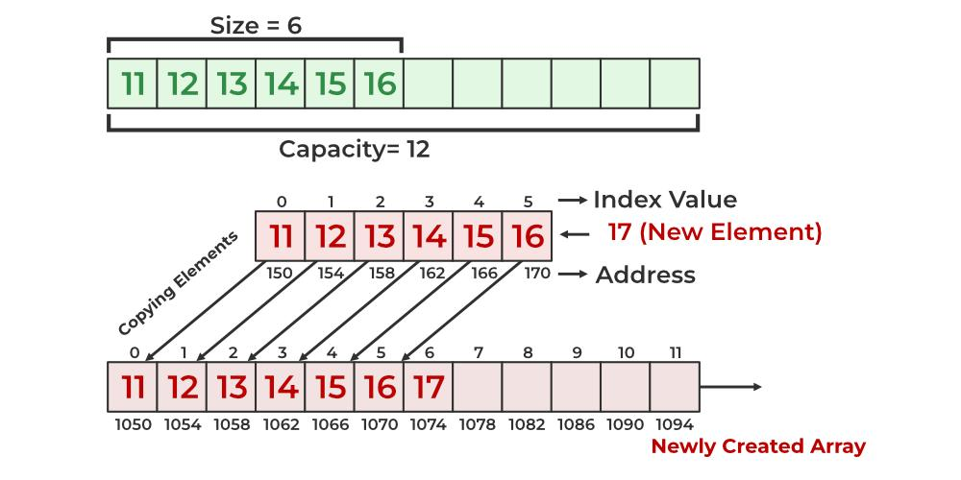
geeksforgeeks.org
Concept: elements are stored contiguously, and the container can grow when needed.
Syntax and operations
vector<int> v = {10, 20, 30};

v.push_back(40); // Add at the end
v.pop_back(); // Remove last element

cout << v[0]; // Access first element
cout << v.at(1); // Access with bounds checking

cout << v.size(); // Number of elements
cout << v.empty(); // Is the vector empty?

v.insert(v.begin() + 1, 15); // Insert at index 1
v.erase(v.begin() + 1); // Erase element at index 1
v.clear(); // Remove all elements
Traversal
vector<int> numbers = {5, 10, 15};

for (int x : numbers) {
cout << x << " ";
}

for (size_t i = 0; i < numbers.size(); i++) {
cout << numbers[i] << " ";
}
Time complexity
Operation | Complexity
Access by index | \(O(1)\)
push_back() | Amortized \(O(1)\)
pop_back() | \(O(1)\)
Insert/erase in middle | \(O(n)\)
Search an unsorted vector | \(O(n)\)
Sort using sort() | \(O(n\log n)\)
Use vector when:
- You need a dynamic array.
- You need frequent index-based access.
- You need to sort data or use binary search.
- You are implementing arrays, DP tables, adjacency lists or answer collections.
Interview tip: vector is the default choice for many DSA problems unless another structure has a clear advantage.
3. String — Text Processing
std::string stores and manages sequences of characters.
string s = "programming";

cout << s.size(); // Length
cout << s[0]; // First character
cout << s.substr(0, 7); // "program"
cout << s.find("gram"); // Starting position
Other common operations:
s += " language";
s.push_back('!');
s.pop_back();

reverse(s.begin(), s.end());
sort(s.begin(), s.end());
sort() sorts characters by their character ordering, not by language-specific dictionary rules.
Character frequency
string s = "banana";
vector<int> freq(26, 0);

for (char ch : s) {
if (ch >= 'a' && ch <= 'z') {
freq[ch - 'a']++;
}
}
This frequency-array approach works for lowercase English letters. Use a map or another suitable structure for a broader character set.
Operation | Typical complexity
Access character | \(O(1)\)
Length | \(O(1)\)
Find substring | Depends on search algorithm and input
Append character | Amortized \(O(1)\)
Reverse characters | \(O(n)\)
Sort characters | \(O(n\log n)\)
Use string when: Solving palindrome, anagram, substring, pattern matching, text-processing and character-frequency problems.
4. Pair — Store Two Related Values
A pair holds two values, which can have different types.
pair<int, string> student = {101, "Harshit"};

cout << student.first; // 101
cout << student.second; // Harshit
Create a pair with:
auto p = make_pair(10, 20);
Vector of pairs
vector<pair<int, int>> points = {
{2, 5},
{1, 8},
{3, 4}
};

sort(points.begin(), points.end());
Pairs are compared lexicographically: first by .first, then by .second if the first values are equal. Therefore, the sorted order is {1,8}, {2,5}, {3,4}.
Operation | Complexity
Access .first / .second | \(O(1)\)
Construct or copy a pair of ordinary values | \(O(1)\)
Use pair when:
- Storing coordinates (x, y).
- Storing (value, index).
- Representing graph edges (neighbor, weight).
- Sorting items by one field and using the other to break ties.
For three or more semantically named fields, consider a struct instead.
5. Stack — Last In, First Out (LIFO)
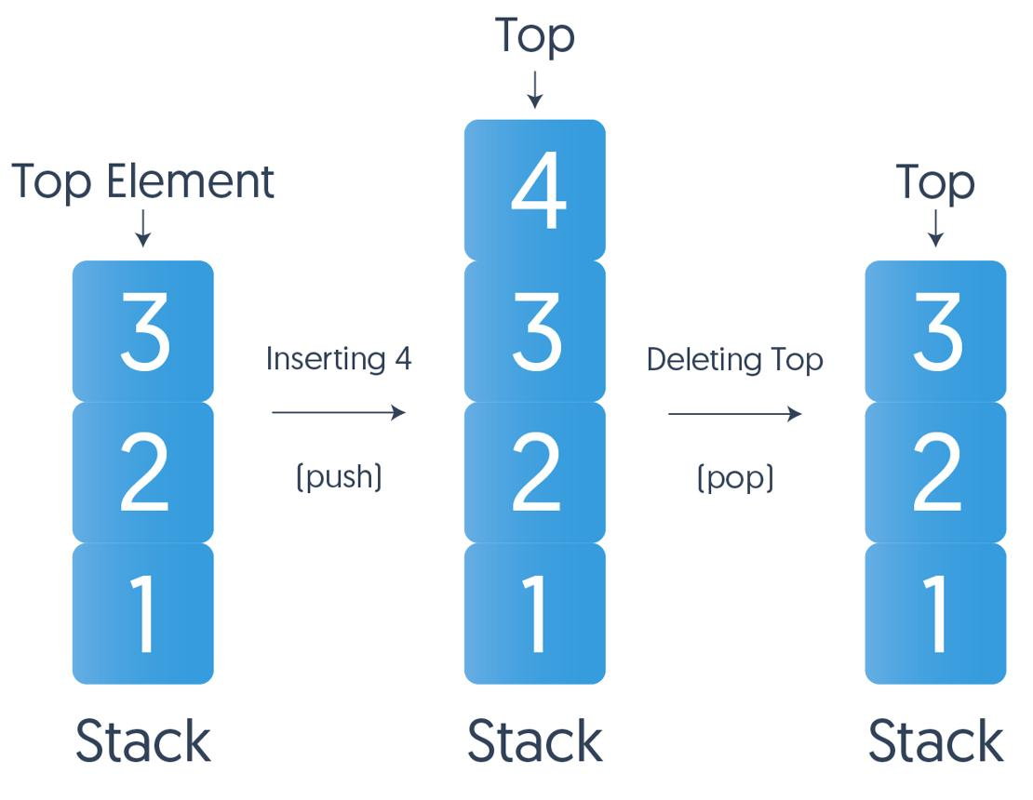
interviewkickstart.com
A stack removes the most recently inserted element first.
Think of a stack of plates: the last plate placed on top is the first one removed.
stack<int> st;

st.push(10);
st.push(20);
st.push(30);

cout << st.top(); // 30

st.pop(); // Removes 30

cout << st.top(); // 20
cout << st.size();
cout << st.empty();
pop() removes the element but does not return it.
Complexity
Operation | Complexity
push() | \(O(1)\)
pop() | \(O(1)\)
top() | \(O(1)\)
empty() / size() | \(O(1)\)
Use cases
- Balanced parentheses.
- Undo/redo systems.
- Function-call stacks.
- Depth-first search (DFS).
- Next greater element.
- Monotonic stack problems.
- Expression evaluation.
Example: Valid parentheses often uses a stack to match every closing bracket with the most recent unmatched opening bracket.
Important: Check st.empty() before calling st.top() or st.pop().
6. Queue — First In, First Out (FIFO)
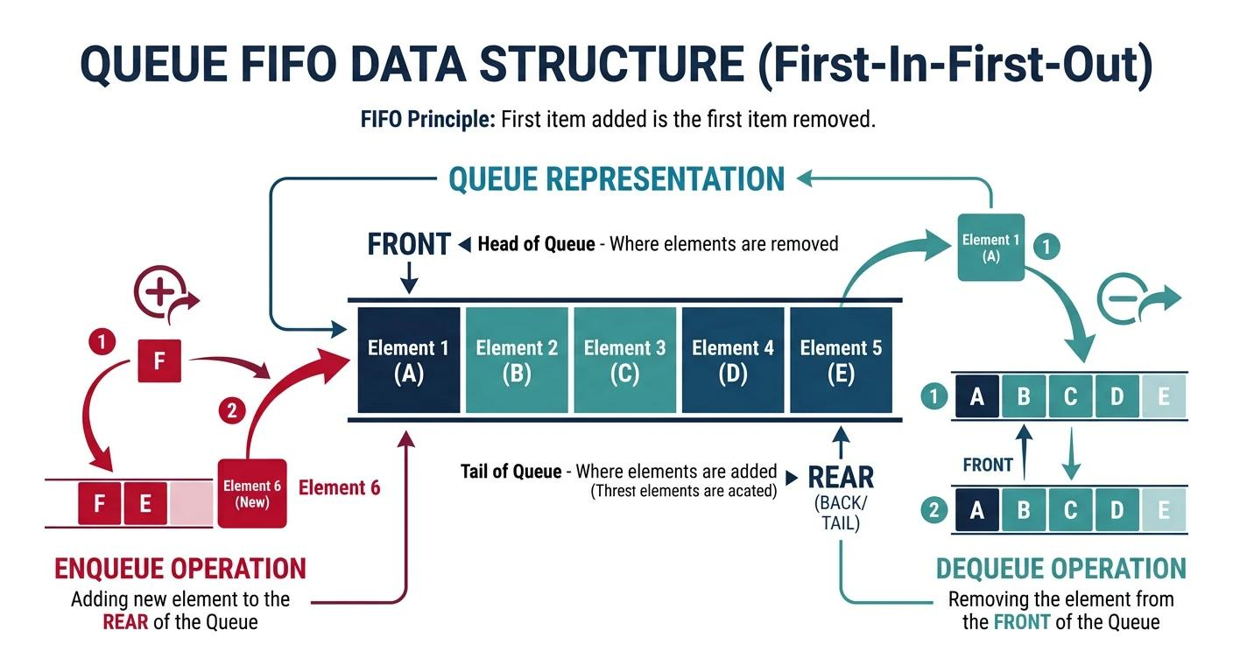
wasilzafar.com
A queue removes the earliest inserted element first, like people waiting in a line.
queue<int> q;

q.push(10);
q.push(20);
q.push(30);

cout << q.front(); // 10
cout << q.back(); // 30

q.pop(); // Removes 10

cout << q.front(); // 20
Complexity
Operation | Complexity
push() | \(O(1)\)
pop() | \(O(1)\)
front() / back() | \(O(1)\)
Use cases
- Breadth-first search (BFS).
- Level-order tree traversal.
- Scheduling tasks in arrival order.
- Simulating waiting lines.
- Processing events in FIFO order.
DSA connection: BFS typically uses a queue because nodes are explored in the order they are discovered, producing shortest paths in an unweighted graph.

7. Deque — Double-Ended Queue
A deque allows insertion and removal at both ends.
deque<int> dq;

dq.push_back(10);
dq.push_back(20);
dq.push_front(5);

cout << dq.front(); // 5
cout << dq.back(); // 20

dq.pop_front();
dq.pop_back();
It also supports random access:
cout << dq[0];
Complexity
Operation | Complexity
Insert/remove at either end | \(O(1)\)
Access by index | \(O(1)\)
Insert/erase in the middle | \(O(n)\)
Use cases
- Sliding-window maximum/minimum.
- Maintaining candidates at both ends.
- Palindrome checks from both ends.
- Work queues that need front and back operations.
Deque versus vector: Both support random access. A vector is often better for general dynamic arrays, while a deque is useful when frequent insertions/removals at the front and back are required.
8. Priority Queue — Highest Priority First
A priority_queue returns the highest-priority element first. By default, it is a max-heap, so the largest value is at the top.
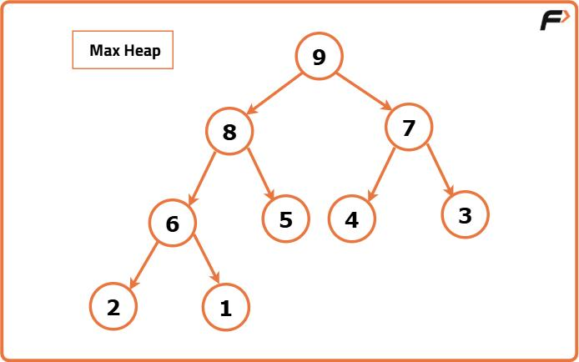
takeuforward.org
Max-heap
priority_queue<int> pq;

pq.push(10);
pq.push(40);
pq.push(20);

cout << pq.top(); // 40

pq.pop(); // Removes 40
cout << pq.top(); // 20
Min-heap
priority_queue<int, vector<int>, greater<int>> minHeap;

minHeap.push(10);
minHeap.push(40);
minHeap.push(20);

cout << minHeap.top(); // 10
Complexity
Operation | Complexity
top() | \(O(1)\)
push() | \(O(\log n)\)
pop() | \(O(\log n)\)
Construct heap from a range | \(O(n)\)
Use cases
- Finding the kth largest/smallest element.
- Top-k frequent elements.
- Dijkstra's shortest-path algorithm.
- Prim's minimum spanning tree algorithm.
- Event scheduling by priority.
- Repeatedly extracting the minimum or maximum.
Remember: A priority queue does not keep all elements in sorted order for iteration. It guarantees access to the highest-priority element.

9. Set — Unique, Sorted Values
A set stores unique keys in sorted order, usually implemented as a balanced search tree.
set<int> s;

s.insert(30);
s.insert(10);
s.insert(20);
s.insert(10); // Duplicate ignored

for (int x : s) {
cout << x << " ";
}

// Output: 10 20 30
Common operations:
s.erase(20);

if (s.find(30) != s.end()) {
cout << "Found";
}

cout << s.count(10); // 1 if present, otherwise 0
Complexity
Operation | Complexity
Insert | \(O(\log n)\)
Search | \(O(\log n)\)
Erase by key | \(O(\log n)\)
Traverse all elements | \(O(n)\)
Use cases
- Removing duplicates while maintaining sorted order.
- Checking whether an element exists.
- Finding predecessor/successor using lower_bound() and upper_bound().
- Maintaining a sorted collection of distinct values.
multiset
A multiset permits duplicates while maintaining sorted order.
multiset<int> ms = {10, 10, 20, 30};

cout << ms.count(10); // 2
One subtlety: ms.erase(10) removes all elements with key 10. To remove only one occurrence:
auto it = ms.find(10);

if (it != ms.end()) {
ms.erase(it);
}

10. Map — Key-Value Pairs in Sorted Order
A map associates each unique key with a value. Keys are maintained in sorted order.
map<string, int> marks;

marks["Harshit"] = 90;
marks["Aman"] = 85;
marks["Riya"] = 95;

cout << marks["Harshit"]; // 90
Traversal
for (const auto &entry : marks) {
cout << entry.first << " "
<< entry.second << '\n';
}
Keys appear in sorted order, so the names are not necessarily printed in insertion order.
Important operations
marks.insert({"Karan", 80});

auto it = marks.find("Aman");

if (it != marks.end()) {
cout << it->second;
}

marks.erase("Riya");
Complexity
Operation | Complexity
Insert | \(O(\log n)\)
Search | \(O(\log n)\)
Erase by key | \(O(\log n)\)
Access with operator[] | \(O(\log n)\)
Important: marks[key] inserts a new key with a value-initialized mapped value if the key does not exist. Use find() or contains() when you only want to check for existence. contains() is available since C++20.
Use cases
- Frequency counting.
- Student ID to marks mapping.
- Maintaining sorted key-value data.
- Grouping information by key.
- Dynamic programming states keyed by a value or tuple.

11. Unordered Set and Unordered Map
These structures are generally implemented using hash tables.
A. unordered_set
Stores unique values without maintaining sorted order.
unordered_set<int> us = {10, 20, 30};

us.insert(40);
us.erase(20);

if (us.find(30) != us.end()) {
cout << "Found";
}
B. unordered_map
Stores unique keys and their associated values without sorted key order.
unordered_map<string, int> frequency;

string words[] = {"AI", "C++", "AI", "Python", "AI"};

for (const string &word : words) {
frequency[word]++;
}

cout << frequency["AI"]; // 3
This is a common frequency-counting pattern.
Complexity comparison
Operation | map / set | unordered_map / unordered_set
Search | \(O(\log n)\) | Average \(O(1)\), worst \(O(n)\)
Insert | \(O(\log n)\) | Average \(O(1)\), worst \(O(n)\)
Erase by key | \(O(\log n)\) | Average \(O(1)\), worst \(O(n)\)
Maintains sorted order | Yes | No
Hash-table performance depends on hashing and collisions. An unordered container is not guaranteed to be faster for every workload.
Use cases
Choose unordered_set when you need fast average membership checks and don't need sorted values.
Choose unordered_map when you need average constant-time key lookup, frequency counting or a hash-based lookup table.
Choose map or set when you need sorted traversal, ordered queries or predecessor/successor operations.
12. Iterators
An iterator is an object used to access and traverse elements of a container.
vector<int> v = {10, 20, 30};

vector<int>::iterator it = v.begin();

cout << *it; // 10

++it;
cout << *it; // 20
Important iterator functions
Function | Meaning
begin() | Iterator to first element
end() | Iterator one position past the last element
rbegin() | Reverse iterator to last element
rend() | Reverse iterator one position before the first
cbegin() | Constant iterator to first element
cend() | Constant iterator one past the last
Important: end() is not a valid element. Never dereference it.
Iterator traversal
vector<int> v = {5, 10, 15};

for (auto it = v.begin(); it != v.end(); ++it) {
cout << *it << " ";
}
Reverse traversal
for (auto it = v.rbegin(); it != v.rend(); ++it) {
cout << *it << " ";
}
Iterators and algorithms
vector<int> v = {40, 10, 30, 20};

sort(v.begin(), v.end());

auto it = find(v.begin(), v.end(), 30);

if (it != v.end()) {
cout << "Found at index "
<< distance(v.begin(), it);
}
distance() is constant-time for random-access iterators such as vector iterators, but can take linear time for some other iterator categories.
Iterator invalidation
An iterator can become invalid after certain container modifications.
- Vector: reallocation can invalidate all iterators, references and pointers to elements. Insertions/erasures can also invalidate some of them.
- Map/set: insertion generally preserves existing iterators; erasing an element invalidates iterators to that element.
- Unordered containers: rehashing can invalidate iterators.
- Deque: invalidation rules depend on the operation and which iterator/reference is used.
After modifying a container, understand its invalidation rules before reusing old iterators.

13. STL Algorithms You Must Revise
The <algorithm> header contains frequently used functions.
vector<int> v = {5, 2, 8, 1, 3};

sort(v.begin(), v.end());
reverse(v.begin(), v.end());

auto it = find(v.begin(), v.end(), 5);

int maximum = *max_element(v.begin(), v.end());
int minimum = *min_element(v.begin(), v.end());

int total = accumulate(v.begin(), v.end(), 0);
accumulate() requires <numeric>.
More useful algorithms:
Algorithm | Purpose | Typical complexity
sort() | Sort range | \(O(n\log n)\)
reverse() | Reverse range | \(O(n)\)
find() | Linear search | \(O(n)\)
count() | Count matching values | \(O(n)\)
binary_search() | Search sorted range | \(O(\log n)\)
lower_bound() | First element not less than target | \(O(\log n)\) on random-access ranges
upper_bound() | First element greater than target | \(O(\log n)\) on random-access ranges
unique() | Move consecutive duplicates to the end of the logical range | \(O(n)\)
accumulate() | Sum or accumulate values | \(O(n)\)
unique() does not resize a vector by itself. A common duplicate-removal pattern for a vector is:
sort(v.begin(), v.end());
v.erase(unique(v.begin(), v.end()), v.end());
This sorts the values and removes duplicates from the resulting vector.

14. Which Data Structure Should You Choose?
This is the most important part of the revision: connect the problem's requirements to the data structure.
DSA decision guide
Need index-based access and a resizable sequence?
Choose vector.
Example: array problems, DP tables, sorting.
Need the most recently added item first?
Choose stack.
Example: parentheses, DFS, next greater element.
Need first-in-first-out processing?
Choose queue.
Example: BFS and level-order traversal.
Need efficient operations at both ends?
Choose deque.
Example: sliding-window maximum.
Need the current minimum or maximum repeatedly?
Choose priority_queue.
Example: kth largest element, Dijkstra's algorithm.
Need unique sorted values?
Choose set.
Example: deduplication, ordered membership queries.
Need key-value lookup?
Choose map or unordered_map.
Example: frequencies, ID lookup, memoization.
Common problem-to-container mapping
DSA problem | Recommended structure
Two Sum with fast lookup | unordered_map
Remove duplicates and keep sorted order | set
Balanced parentheses | stack
BFS on a graph | queue
Sliding-window maximum | deque
Kth largest element | priority_queue
Character frequency | unordered_map or frequency array
Top-k frequent elements | unordered_map + priority_queue
Sorted key-value lookup | map
Dynamic sequence with index access | vector
Graph adjacency list | vector<vector<int>> or vector<vector<pair<int,int>>>

Day 373 completion target
By the end of this revision, you should be able to:
- Write the basic syntax for every listed container.
- Explain each container's ordering, uniqueness and access rules.
- Recall its common operation complexities.
- Select an appropriate data structure for a DSA problem.
- Combine STL containers with algorithms such as sort, find, lower_bound and accumulate.
Core rule: Choose the data structure according to the operations the problem performs most frequently—not simply because you already know how to use it.

